Halloween Applique Cuddle Quilt
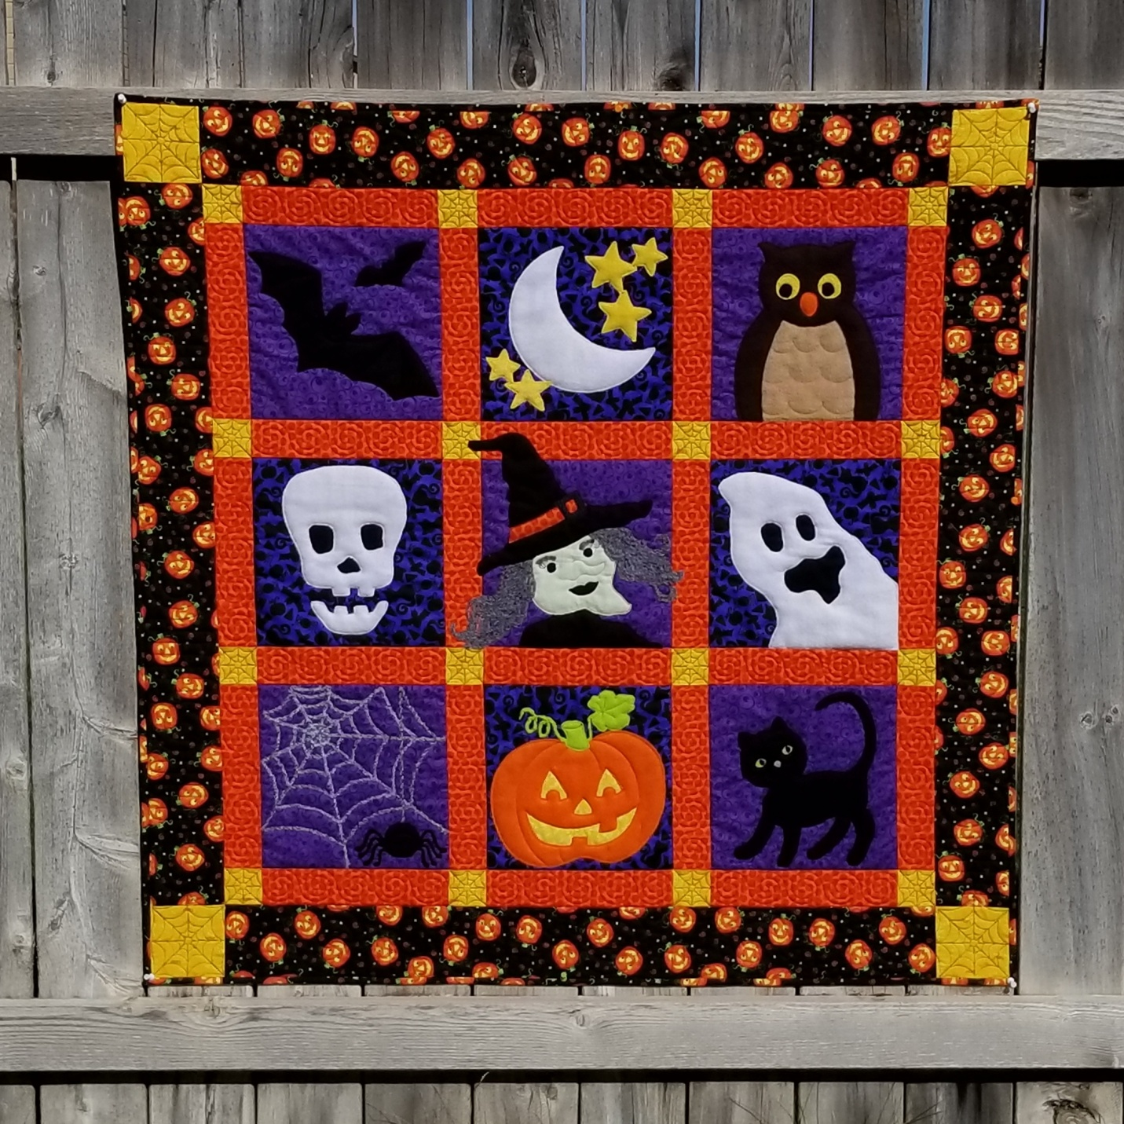

General Instructions
The appliques are made with fleece which makes a soft dimensional design and quilt fabric with soft double-sided fusible attached to the wrong side of fabric, or a combination of both. The fusible will help provide traction to keep the quilt fabric from slipping during stitching and can be pressed to complete the bond after the applique is stitched and trimmed. Fleece needs no fusible. Each applique pattern is designed to double stitch to reinforce the edges. Make sure controller definitions are set to pause at jump stitch. Use Crosshairs to place fabric over the section to be stitched making sure to completely cover design element before quilting. When stitcher pauses, move stitcher out of the way and trim, then place fabric over next section using crosshairs to center. Move stitcher over fabric, press continue to stitch. Continue until each section is complete. Using a spoon foot will help the stitcher move easily over the fabric layers. A couching foot can be used to add yarn embellishment.
Materials Needed (Applique materials listed under each applique)
Quilt top measurements based on 42” useable width fabric
2/3 yard purple tone on tone Halloween print fabric. Cut 5-10 ½ inch squares
1/3 yard blue tone on tone Halloween print fabric. Cut 4- 10 ½ inch squares
½ yard orange for sashing. Cut 24 – 2 ½ x 10 ½ inches.
1/4 yard yellow for cornerstones. Cut 16 – 2 ½ inch squares, and 4 – 4 ½ inch squares
*½ yard Halloween print fabric with black background for borders. Cut 4 – 4 ½ x 38 ½ inches
3 yards Halloween print with black background for backing. (Black background helps obscure stitching lines.) *there is enough from this backing yardage for borders if they are cut lengthwise.
1/3 yard fabric for binding. Cut 5 – 2 ¼ inch lengths
Sew together to make 3 rows of 3 blocks with sashing and cornerstones in between and 4 ½ inch borders with cornerstones to make 46 x 46” quilt top. (See Photo) Press, load, and Stitch in the Ditch to stabilize. Quilt borders, sashing, and cornerstones. Add applique to blocks. Unload, trim and bind.
Recommended: Spoon foot, Couching foot, extended plate, applique scissors, black quilting thread.
Bats
Materials and Order of Stitching
10 in square black fleece
Large bat
Left/Right Eyes and Nose stitched detail
Small bat
Lay fleece over block. Stitch both bats before trimming.
Moon and Stars
Order of Stitching and Materials
Moon 8 inch square white fleece
Stars 10 inch square yellow fleece or 1-4 inch and 1-6 inch squares yellow fleece
Lower left group of 2 stars
Upper right group of 3 stars
Trim after each
Owl
Order of Stitching and Materials
Breast 7 inch square tan fleece
Head and Wings 10 inch square dark brown fleece
Beak 3 inch square orange fleece
Left/Right Eyes 5 x 3 inches of bright yellow fleece
Left/Right Pupils 5 x 3 inch black
Trim after each
Skull
Optional 8 in square black fabric with fusible for reverse applique under eye and nose sockets
If using optional black, baste and trim before placing white for skull.
Skull 10 inch white fleece
Jaw
Left/Right Eye Sockets
Nose Socket
Stitch all then trim. Carefully lift fabric away from background to trim inside of eye and nose sockets.
Witch
Order of Stitching and Materials
Dress 9 x 5 inch black fabric with fusible attached to wrong side. Use leftover from dress for lips and pupils
Head and Nose 7 inch square green fabric with fusible adhered to wrong side. Nose is single stitched detail on head.
Lips scraps from dress
Left/Right Eyes 2 x 4 inch white fabric with fusible adhered to wrong side.
Left/Right Pupils scraps from dress. Trim before eyelash detail.
Left/Right Eyelashes detail
*If using yarn to add dimension to eyebrows and hair change to couching foot. Insert yarn.
Left/Right Eyebrows single stitched for ease of use with yarn
Left/Right Hair Either 10 x 14 inch gray fleece or Variegated Gray Yarn with couching foot for hair detail. If using couching foot with yarn for hair, when computer outline finishes stitching click cancel, switch to regulated mode and freehand fill in outline of hair with more yarn. Add a curl or two. Use restart to move to the next section of applique.
Hat 9 x 11 inch black fabric with fusible adhered to wrong side
Hat Band 4 x 5 inch bright color fabric with fusible adhered to wrong side
Buckle 3 x 3 inch square gray or silver fabric with fusible as reverse applique to reveal band on the inside of the Buckle
Trim after each.
Ghost
Order of Stitching and Materials
*Optional 7 x 7 inch square black background for behind ghost eyes and mouth. Baste and trim.
Ghost 11 inch square white fleece
Mouth
Left/Right eyes
Stitch all then trim. Carefully lift fabric away from background to trim inside of eyes and mouth.
Spider
Order of Stitching and Materials
Web (has 1 jump stitch) Optional Yarn for web. Use couching foot.
Spider Abdomen 3 inch square black fleece. Trim
Head and Legs 4 x 7 inches black fleece.
Left/Right eye stitched detail
Mouth stitched detail.
Trim
Jack-o-Lantern
Background for eyes, nose and mouth reverse applique 9 x 7 inches yellow fabric with fusible adhered to wrong side.
Pumpkin 9 x 11 inches orange fleece (trim pumpkin before stitching vine, stem and leaf
Left/Right Eye
Mouth
Nose
5 x 7 inches Bright Green fleece
Curly Vine
Leaf trim before stem
Stem
Cat
Inside Leg 4 x 3 inches black fleece
Cat 11 x 10 inches black fleece
Left/Right Eyes 3 x 2 inches green fleece
Left/Right Pupils 3 x 2 inches black
Muzzle stitched detail
Nose 2 x 2 inch gray fleece
Left/Right Eyebrows stitched detail
Left/Right Whiskers stitched detail
Trim after each.

